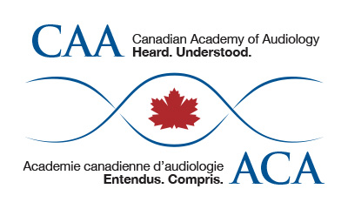
CAA Conference Student Volunteer Form

Name
Email Address
Address 1
Address 2
Phone Number
School
Year of Study
T-Shirt Size (XS, S, M, L, XL)

Please check all that apply to you:

☐ I am available to volunteer on Tuesday, October 20 from 3:00 p.m. to 7:00 p.m.
☐ I would be interested in working as a photographer
☐ I would be interested in working as a videographer
☐ I own and am willing to use my own digital camera
☐ I own and am willing to use my own digital video recorder

Please note that volunteers are chosen on a first come, first served basis. Your assignments will be determined by the Volunteer Coordinator. All assignments will run between 4 and 6 hours.

Student volunteers help with educational sessions, meetings, social events, exhibit hall, registration support, and conference material assembly at the CAA conference. In exchange, volunteers will receive free registration for the conference.
Qualifications:
• current student member of CAA and
• actively enrolled in a graduate Audiology program at the time of the CAA conference (October 21-24, 2015).
Selection priority:
Year of study priority:
• students in their second or final year of study at a Canadian Audiology program in October 2015.
Timing priority:
• September 4 to 13: Six volunteer positions are filled by students from each of the 5 Canadian graduate audiology programs on a time of receipt of application basis
• September 14: The 6 per University program quota is lifted and all remaining positions are filled on the basis of time of receipt of application starting Sept 4
All students accepted as volunteers will have their registration fees refunded if they have already registered for the conference.
Your obligations as a student volunteer:
• You will be given one of the student volunteer task assignments (approximately 4 to 6 hours each).
• Attend the Student Volunteer Reception on Wednesday evening (5:00 pm – 6:00 pm), where you will receive final instructions for the conference.
• Students who do not fulfill their assignments will be responsible for the on-site price of student member registration.
For further information, please contact CAA conference@canadianaudiology.ca.

Return form via email to conference@canadianaudiology.ca.

