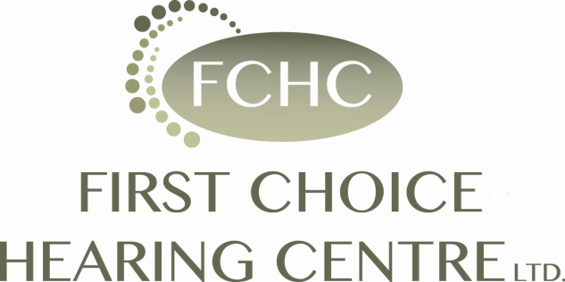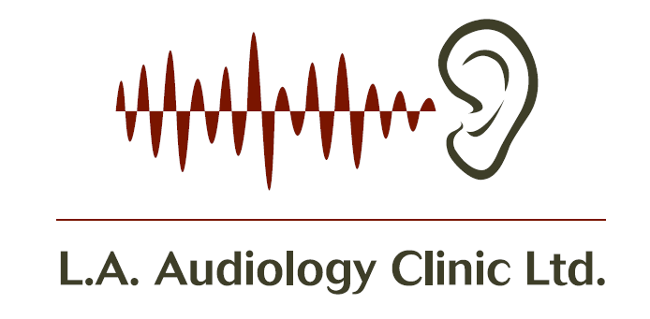

L.A. Audiology Clinic Ltd. / First Choice Hearing Centre Ltd. are currently accepting applications for a permanent Full-time Audiologist to join our team. If you are seeking an opportunity to work for a privately owned clinic that is based on excellent client care and employee fulfillment then you may be who we are looking for.

Description:
L.A. Audiology Clinic Ltd (located in Leduc Alberta) and First Choice Hearing Centre Ltd (located in Fort Saskatchewan, Alberta) are committed to providing quality hearing healthcare to our clients.

Responsibilities include but are not limited to:
Comprehensive audiological and amplification services to clients of all ages.
Counseling and education for clients with hearing loss and treatment options
Hearing aid and FM dispensing
Hearing aid verification, follow-ups, cleaning and repairs
Educational Audiology services

Requirements/Qualifications:
Master’s Degree in Audiology or Au.D Degree from an accredited University.
Current or eligible for registration with the Alberta College of Speech-Language Pathologists and Audiologists.
Valid Driver’s license and access to motor vehicle. Travel is a requirement of this position.
Strong verbal and written communication skills.
Excellent problem solving and interpersonal skills.
Must have an ability to prioritize, multi-task and handle a high volume of clients.
Must work well in a team environment and independently.
Must possess a high level of professionalism and adherence to professional ethics, principles and organizational values.

We Offer:
Competitive wages and Benefit package
Continued opportunities for learning
An enjoyable and diverse working environment.

If you feel you may be well suited for this position please forward your resume to: koren@laaudiology.ca

