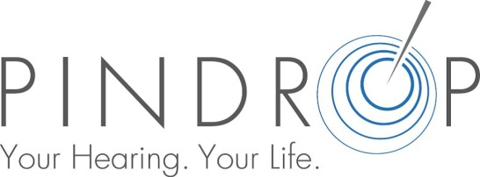

We are excited to announce that Pindrop Hearing Centre is once again expanding and are looking for Audiologists to join our team in Owen Sound, Ontario. At Pindrop Hearing we realize it’s not about hearing loss, it’s about being part of the conversation. Our compassionate hearing professionals understand that each person’s challenges are unique. We enhance lives by pairing our expertise with industry-leading technology so that our clients can reconnect with those that matter most.
Job Description:
Work requirements include basic diagnostic procedures and hearing aid selection, fitting and follow-up. Our practice emphasizes counseling and thorough compassionate patient care. The ideal candidates will strive to provide the best outcomes for each patient.
Qualifications:

®Masters in Audiology from a recognized university program
®Current registration with the College of Audiologists and Speech-Language Pathologists is required
®Minimum 3 years clinical experience
®Ability to work independently with little supervision
®Well-developed clinical skills and demonstrated thoroughness, accuracy and attention to detail and commitment to quality improvement initiatives

If you enjoy interacting with people and have the experience we are looking for, this may be the opportunity for you. Email your resume directly to info@soundauthority.ca. We thank you for your interest, but only candidates selected for an interview will be contacted. No phone calls please.

