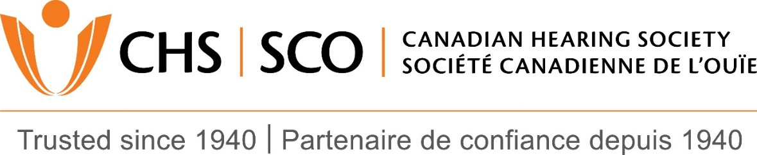

Audiologists for CHS Hamilton & CHS Ottawa
The Canadian Hearing Society (CHS) is seeking audiologists for our Ottawa and Hamilton locations.
Founded in 1940 to serve hard-of-hearing and Deaf individuals, CHS is the largest organization of its kind in North America offering a wide range of services including audiology, mental health counseling, accessibility services and more. As an audiologist at CHS, you will be part of an integrated and highly trained team of professionals evaluating and assisting individuals with hearing loss, spanning pediatric to geriatric populations.
Strong clinical and counseling skills that facilitate acceptance of hearing loss and related solutions are essential. The ideal candidate will be committed to outstanding client care and a team player capable of establishing rapport and interacting professionally with clients, physicians and others. This is a dispensing position requiring exceptional customer service skills along with strong hearing instrument product knowledge.
Visit our website at www.chs.ca or contact Rex Banks, Au.D., at rbanks@chs.ca if you would like to learn more about CHS. This is a great opportunity to join the CHS team! CASLPO mentorship available for new graduates.
For more information about the positions and to apply, please visit the below links.
Ottawa
https://www.chs.ca/august-30-2016-audiologist-ottawa-2016-043
Hamilton
https://www.chs.ca/july-29-2016-audiologist-hamilton-competition-2016-034
We thank all applicants in advance; however only individuals selected for an interview will be contacted. All applications will be kept confidential

