**Head Office** - 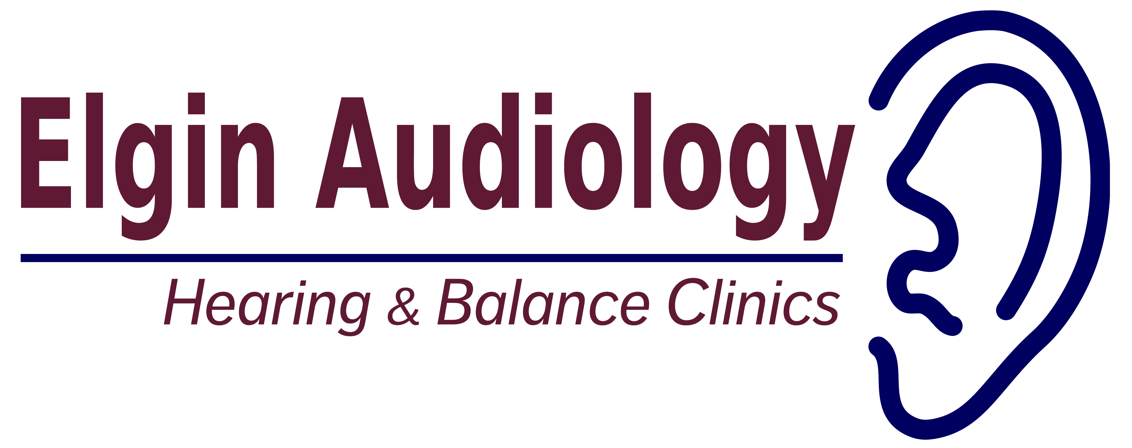66 West Ave., Suite 101

St. Thomas, ON, N5R 5H7

**519-637-5925**

fax 519-637-5924

**www.elginaudiology.com**

____________________________________________________________________________________

