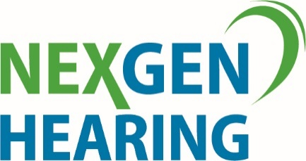

Audiologists - Join the NexGen team on beautiful Vancouver Island

We are seeking an experienced Audiologist who is a great communicator and problem solver looking for a long-term position in a stunning location with a supportive and experienced team.

Join the NexGen Hearing team on beautiful Vancouver Island. Due to the growth and success of our hearing clinics, we are seeking a motivated Audiologist to join one of our Victoria clinics. This position offers both lifestyle and professional challenge.

If you possess the following skills, you are the candidate we are looking for:
- A passion to provide extraordinary levels of customer service.
- The ability to provide the best experience and highest quality care for our clients.
- Strong technical skills with audiometric equipment and computers.
- Registration (or eligible to register) with the College of Speech and Hearing Health Professionals of BC in accordance with professional requirements for an AUD/HIP or HIP.

We offer a competitive total compensation package with an attractive base salary, performance rewards program; a comprehensive benefit plan; professional fee and licensing coverage and career advancement opportunities

Become part of the NexGen family and apply and develop your skills alongside some of Canada’s finest Hearing Care Professionals. It’s a winning combination!

Send your resume and cover letter to careers@nexgenhearing.com indicating your interest in the position.
