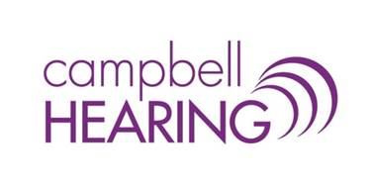
Campbell Hearing is an independently-owned private practice in Charlottetown, Prince Edward Island. We currently have an opening for a full-time audiologist.
Requirements:
Masters degree in Audiology from a recognized, accredited program
Eligible for SAC certification
Proficiency in English (oral and written)

Competencies & Characteristics:
Experience is an asset, but not required
Friendly and professional demeanor
Compassionate and collaborative approach to patient care
Ability to work independently

Responsibilities include, but are not limited to:
Hearing testing for children (aged 4+) & adults
Prescribing and fitting hearing instruments and accessories on adults
Providing counselling and follow-up care for patients and their families
Documentation of patient visits and report writing
Option to offer other services, based on training and area(s) of interest (e.g. cerumen management, auditory processing assessments, tinnitus evaluations)

We offer:
A competitive salary commensurate with qualifications, experience and performance
A positive and supportive work environment
Paid professional association fees
Continuing education & training
Flex hours and benefits available

Please email resume to krista@campbellhearing.ca. Thank you for your interest; only candidates selected for interviews will be contacted.

