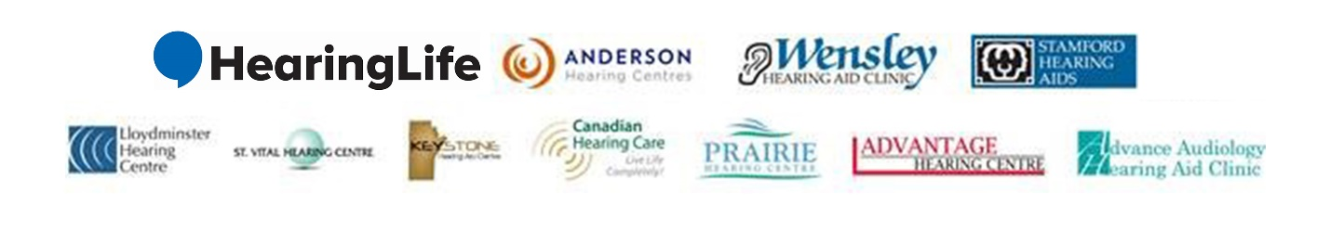
Immediate Audiologist positions available across Canada!
The Audiologist is responsible for effectively treating hearing loss for their clients in a professional, caring and expert manner. The clinician acts in accordance with the required provincial professional licensing standards and in accordance with our own high standards of care and clinical processes and procedures. If you can uphold the highest clinical, diagnostic and commercial skillset and can perform in a high energy professional environment with empathy, compassion and professionalism, if you are driven and would like career opportunities and upward mobility; then we would like to meet with you to discuss immediate opportunities within our group for all clinicians. We are hiring in the following cities:

Lethbridge, AB Owen Sound, ON
Lloydminster, AB North Bay, ON
Saskatoon, SK Sault Ste Marie, ON
Role Responsibilities and Requirements:
- A Strong diagnostic capability and clinical interpretive skillset
- Strong interpersonal, communication and problem solving skills
- Ability to test hearing using a variety of equipment such as audiometers, Tymps, Verifits, VRA in some clinics
- An understanding of various products and solutions for various degrees of hearing loss
- A strong belief in ones skillset and the ability to effectively communicate the solution to the client
- An understanding of various manufacturer software and Noah
- A strong collaborative personality that works well with others
- PC skillset to a capable degree
- An organized and methodical mindset
- An outgoing driven personality with confidence and enthusiasm about what we do and who we treat and help
Qualifications:
- Must be fully licensed within the province
- Must be in registered and in good standing with the provincial regulatory organization
- Must have Masters degree in Audiology
- Experience is preferred however if you are a recent graduate we would still be very interested in meeting with you
If this opportunity appeals to you please don’t hesitate to reach out to Melissa Bautista at melissab@hirepower.ca in complete confidence. We offer the very best team with regards to support, professional development, clinical freedom and the most aggressive reimbursement package in the industry.

