# Instrument of Proxy

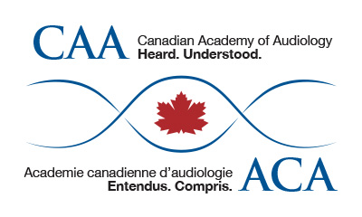

I, ___________________________________________, a member of the Canadian Academy of

Audiology (CAA) hereby appoint _______________________________ who is a member of CAA OR Salima Jiwani, President of CAA, as my proxy to attend, act and vote for me on my behalf at the Annual General Meeting of CAA, to be held the 18th day of October 2018 and at any adjournment thereof, unless and until I am present in person and I hereby revoke any former instrument appointing a proxy for me at the said meeting or any adjournment thereof.

Dated this ________________ day of ___________________ 2018

Member Signature _____________________________________

**Please forward to the CAA National Office by email**

**to** [**tracy.cook@canadianaudiology.ca**](mailto:tracy.cook@canadianaudiology.ca) **by October 1st, 2018.**

**Only full members in good standing may run for office, nominate, and vote.**