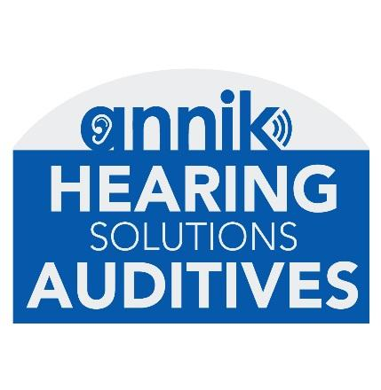
AUDIOLOGIST or Hearing Instrument Specialist - Annik Hearing Solutions
Maternity leave contract until September 2020 with high possibility of ongoing continued permanent position afterwards
Temporary position - 3 or 4 days/week, to be discussed Casselman & Rockland, ON clinics
Annik Hearing Solutions provides attentive and individual care, offering a personalized service.
The priority of the clinic is based on the fundamental principles that remain at the heart of the organization: Integrity, Dedication and Dignity.
Our goal at Annik Hearing Solutions is to detect early hearing loss and offer options so that our patients can enjoy life to the fullest. Our reputation rests on our friendly, caring staff and where the needs of patients are our priority. Our fast and efficient service and the quality of our technologies make us a place of trust.

We are seeking a professional, energetic and compassionate audiologist to join our friendly team for a maternity leave contract with high possibility of becoming a permanent position since the clinic is in continuous growth.

Qualifications & Requirements
- Master’s Degree in Audiology
-Registered in good standing with the College of Audiologists and Speech Language Pathologists of Ontario (CASLPO).
- Hearing aid dispensing experience is preferred. However if you are a recent graduate we would still be very interested in meeting with you.
- Being fluent in both French and English is a must.
- Excellent interpersonal skills and customer service oriented.
- Ability to work as part of a team and also independently.
Position summary
The qualified candidate will be responsible for hearing evaluations as well as prescribing hearing aids, fittings, follow-up care and provide our patients with the best solution for their hearing loss and lifestyle. Travel between both clinic locations is required.
If this describes you and you would like to join our team, please send your cover letter and resume to info@hearingbetter.ca

