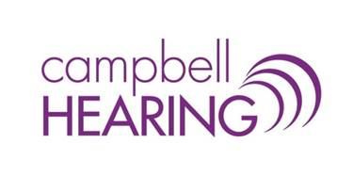
We are growing and looking to add to our team!
Campbell Hearing is an independent, locally-owned hearing healthcare clinic in Charlottetown, PEI. We love what we do and pride ourselves in providing a welcoming, professional environment for patients and staff alike. We are currently seeking a full-time clinical and dispensing audiologist.
Responsibilities include:
- Hearing testing for pediatric (aged 4+) and adult populations
- Hearing aid prescriptions, fittings and follow-up care for adults
- Community outreach and education
- Additional duties based on training and area(s) of interest (e.g. cerumen management, tinnitus counseling)

Requirements/Qualifications:
- Masters degree in Audiology from a recognized, accredited program
- SAC certification
- Compassionate approach to patient care
- Friendly, professional demeanor
- Strong organizational and time management skills
- Strong communication skills (oral and written)
- Able to handle sensitive information in a respectful, confidential manner

We offer a competitive compensation package and a friendly, supportive working environment.
Please email resume to krista@campbellhearing.ca.

