Instrument of Proxy
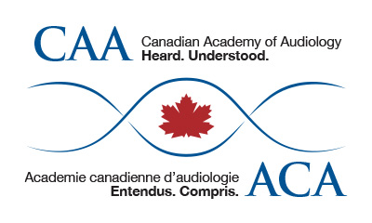

I, ___________________________________________, a member of the Canadian Academy of
Audiology (CAA) hereby appoint _______________________________ Dave Gordey, President of CAA, as my proxy to attend, act and vote for me on my behalf at the Annual General Meeting of CAA, to be held the 1st day of October 2019 and at any adjournment thereof, unless and until I am present in person and I hereby revoke any former instrument appointing a proxy for me at the said meeting or any adjournment thereof.

Dated this ________________ day of ___________________ 2019

Member Signature _____________________________________

Please forward to the CAA National Office by email
to tracy.cook@canadianaudiology.ca by September 24, 2019.

Only full members, or early career members in good standing may vote.

