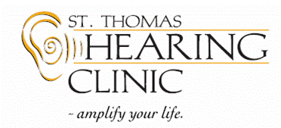

St. Thomas Hearing Clinic is seeking a skilled Audiologist or Hearing Instrument Specialist to join our team. The primary goal at our clinic is to help patients hear the sounds that are most important to them. We treat our patients as family and are seeking a people-focused audiologist or Hearing Instrument Specialist to join us in providing a family level of care. Competitive industry salaries offered.
Among the services we offer to patients are:

- Testing and evaluation of peripheral and auditory processing disorders
- Dispensing and servicing hearing devices and accessories
- Counseling for hearing loss sufferers and their families
- Providing tinnitus management devices and techniques
- Hosting educational workshops and other helpful events

Our ideal candidate will have:

- 2+ years of experience (although all candidates are invited to apply)
- Compassion, patience and empathy
- Cooperative spirit that builds solid relationships with our clients, staff, community and clinic
- Knowledge of current technology: hearing aids, accessories, assistive devices
- Fluency in manufacturers’ programming software
- Competency in equipment maintenance, troubleshooting and performance checks
- Excellent computer skills and competency with Microsoft Office
- Thorough understanding of CASLPO or AHIP guidelines as they apply to all aspects of our profession

Requirements
- Masters of Audiology or equivalent, or Hearing Instrument Specialist Designation
- Current registration/license with our provincial college (or eligibility); or AHIP association
- Eligibility to provide services to clients covered under third party funding in Ontario (e.g., WSIB, ADP, VAC)

Our hometown of St. Thomas is a fabulous community, great for families and single people alike. MoneySense magazine named it one of the Best Places to Live in Canada! Moving expenses negotiable.
Please send your cover letter, resume with references, and your contact information to: tiffanylandon@hotmail.com

