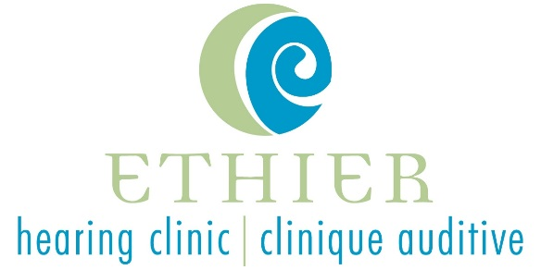
Ethier Hearing Clinic is an independently–owned private practice located in Timmins, Ontario. We are well established in the Timmins and District Hospital, and work closely with the ENT Department. We currently have an opening for a clinical and dispensing audiologist on a part-time or full-time basis. We are offering a relocation package if required, health benefits as well as a competitive salary. If you enjoy the outdoors, being active and surrounded by an amazing community, this is the lifestyle choice for you!
Position Summary
Primary duties include (but are not limited to) diagnosis, assessment, management and prevention of hearing loss (and balance disorders) for private patients as well as patients scheduled through the ENT/Audiology Clinics.

Duties and Responsibilities include, but are not limited to:
- Hearing assessments and diagnostic testing for all ages
- Prescribe, dispense and fit hearing devices and assistive listening devices;
- Perform hearing aid maintenance checks and verification;
- Dispense and fit custom and non-custom earplugs (swim plugs, hearing protection);
- Provide appropriate counseling to individuals with hearing loss (and tinnitus) and their families to reduce communication problems and facilitate adjustments to hearing loss;
- Community outreach

Please note that other duties and responsibilities may also include:
- Central Auditory Processing Testing;
- Supervise audiology and medical students.

Key qualifications:
- Master’s degree in Audiology from a recognized, accredited program;
- Minimum 1 year clinical experience;
- Licensed by CASLPO and ADP.

Key competencies:
- Strong counselling and relationship building skills;
- Ability to work in a group and independently, with effective time management;
- Compassionate approach to hearing health care;
- Strong initiative and problem-solving skills;
- Professional attitude;
- Bilingualism preferable.

Please email resume to methier@tadh.com. I am attending the Conference and therefore am on site; feel free to contact me at (705) 363-7162 if you wish to discuss in person.

Thank you for your interest; only candidates selected for interviews will be contacted.

