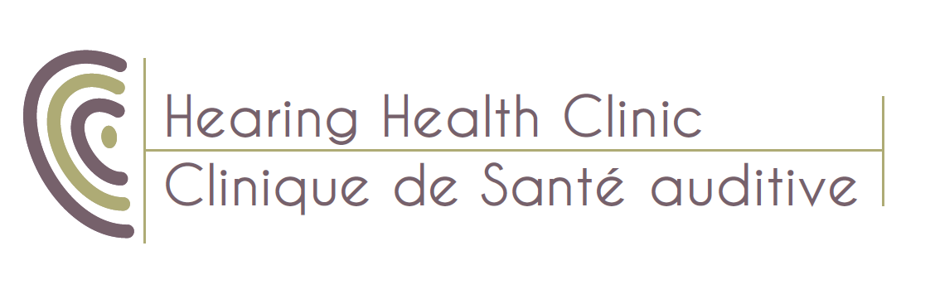

We are seeking highly motivated, dynamic individuals with excellent interpersonal skills for the position of Audiologist ,in the Ottawa area, On

Benefits and Compensation
We offer Dental and Pharmaceutical Drug Plans,
We offer a very competitive annual salary
Must be bilingual English/French

Key Responsibilities:
➢ Ability to perform Hearing Tests / Verifications using a variety of equipment such as audiometers, Tymps, Verifits,
➢ Have a general understanding for most H/A MFG with focus on specific office brands
➢ Proficient with matching and setting up required H/A accessories
➢ Strong ability to communicate with patients and counsel to their specific needs
➢ A strong ability to trouble shoot
➢ Strong communication skills …
➢ Knowledgeable about WSIB, VAC, ODSP ADP and NIHB Procedures.
Qualifications
➢ Must be fully licensed within the province of Ontario.
➢ Must be in registered and in good standing with ADP, CASLPO
➢ MUST have an outgoing fun personality or ability to make strong connections with patients
➢ Experience is preferred; however, we are willing to invest into the right candidate lacking experience.
Contact Hearing Health Clinic in confidence at: info@hearingouie.ca

