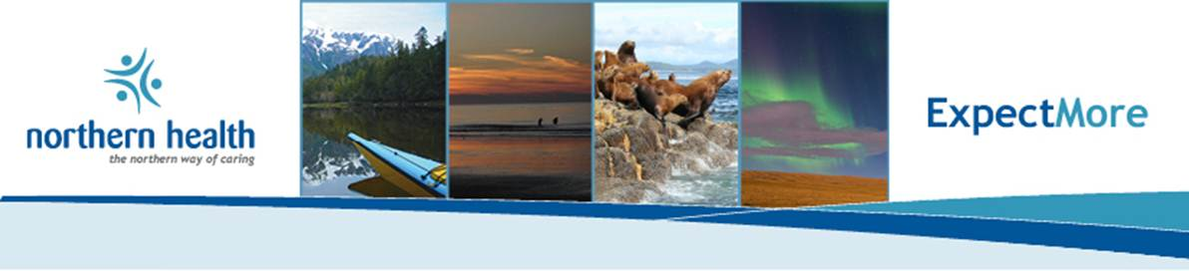

**Nature knows no limits. Neither should your career.**

Sometimes you have to make a bold move, leaving behind the everyday to join an organization that’s truly different. If you’re looking for outstanding career opportunities and enjoying an outstanding quality of life, you owe it to yourself to choose Northern Health in beautiful Northern British Columbia.

**Audiology Program Lead**

**Full Time, Fort St. John, BC**

The Public Health Audiology Program Lead provides operational leadership for audiology services including the supervision of audiology staff in the Northeast HSDA. In addition, the Lead provides clinical audiology services to infants, children and youth, as well as consultative and educational services to professionals and the community.

**What you bring**

The successful applicant will have a Master’s degree in Audiology from a recognized university program, current registration within the College of Speech and Hearing Health Professionals of B.C. to practice as an Audiologist, two (2) years clinically related experience, including supervisory experience or an equivalent combination of education, training and experience and also a current valid Class 5 B.C. Drivers License and access to personal vehicle for business related purposes.

**Check out what else you can expect by choosing Northern Health!**

* Generous relocation package
* Northern living allowance in rural communities
* Great benefit packages and pension
* Unmatched work-life balance
* Affordable housing prices in most of our communities
* Four season, endless outdoor adventure

**Where else would you want to be working!**

To apply on-line**,** check out this job on our website at

**<https://expectmore.northernhealth.ca/ViewPosting.aspx?id=5470637&f=0-0-24--0-0>**