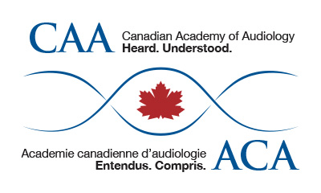
Nomination to the Board of Directors

The Canadian Academy of Audiology, (CAA) is an active and progressive association. We encourage you to be more involved in providing strategic direction for your profession by becoming a Board Member.
To nominate yourself for a position, you must be a Professional Member in good standing. Please complete the form below and return to neil.hardie@canadianaudiology.ca. We ask that you provide the name and email contact information of two fellow active members to act as your supporters.
Date
First Name
Last Name
Address
City
Province
Postal Code
Telephone Number
Email Address
Employment and Interest Areas
(or attach CV)
Indicate why you are interested in becoming a member of the Board of Directors of CAA

Name and email of Supporter 1
Name and email of Supporter 2

