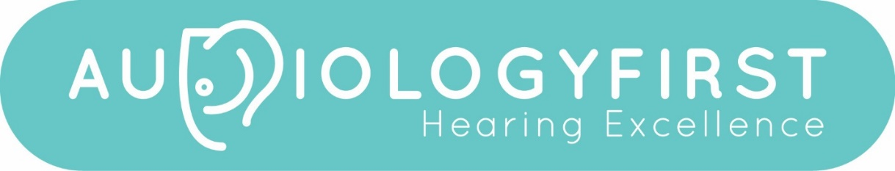

COME WORK WITH US!

Audiology First is growing! We are looking for a full time Audiologist for a long term career with us at Audiology First. Qualified Audiologists should apply now for this great opportunity.

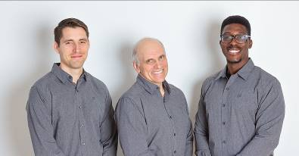
Our Audiologists.
Glenn Hole R.Aud (MSc, BSc), Dr Thomas Copps (AuD) and Dr Femi Coo (AuD)

Audiology First was established in 2015 and is situated in a beautiful spacious building in Lethbridge, Alberta. We are unique in that all of our clinicians are registered Audiologists.

We are not a hardline ‘by the numbers’ clinic, but instead we put the patient first – focusing on diagnostics, outcomes and patient satisfaction. As a result, word of mouth and reputation drives many clients towards our clinic. We have earned the trust and respect of both local primary care physicians and top ENT surgeons in our province. We pride ourselves on being a progressive force in our profession, with aspirations to expand towards broader audiology services. We aim to maintain our skills at the highest level possible.

About Lethbridge
Lethbridge is a small city about 2 hours south of Calgary. For professionals, it benefits from low traffic densities and short commute times. It is a great city for both younger individuals and families. The city has great shopping facilities, low house prices, wonderful outdoor spaces, great restaurants and city facilities. It also offers great access to Calgary, the USA border and the Canadian Rockies.

What we offer:
- A competitive salary (specify your salary range in your application).
- Your own spacious testing room complete with audiometer, tymp, OAE, reflexes, high frequency audiometry, Verifit 2 (including autoREM) and booth. We also have AMTAS automated testing, and basic vestibular screening tools.
- A common sense, low stress work environment.
- A single location. No travel required!
- Generous appointment durations to achieve excellence with each person.
- Excellent medical benefits
- Fitness/Exercise membership a great local gym if wanted (we are a very active fit group).
- 3 weeks’ vacation.
- Weekday hours (no weekends!)
- Professional development opportunities.
- Paid annual professional membership dues (ACSLPA) & paid liability insurance.
- A collaborative, client focused work ethic.
- Opportunities to participate in research.

Daily tasks and responsibilities
- Our primary focus is adult hearing loss diagnostics, amplification, rehabilitation and research.
- Maintain excellent relationships with patients, physicians and referral sources.
- Participate in our research data collection.
- Fit and maintain hearing aids to evidence based standards (we are not a click and fit clinic!)
- Provide ideas and suggestions for making our patient care better.
- To take part in future projects and initiatives within the clinic.

Qualifications required.
- You need a good sense of humor and a good perspective on balancing work and life!
- MSc or AuD in Audiology with registration in Alberta, or ability to become registered.
- 1-2 years hearing aid dispensing experience preferred but not essential. Personality fit is our first priority.
- New grads will be considered, mentoring and training can be provided as needed (we don’t bite).
- Skill and flexibility at fitting hearing aids – we mainly work with Oticon, but we do provide other brands for specific patient needs. We can offer training with any technology or brand.
- The ability to work in a team environment.
- The ability to interact professionally with colleagues.
- The ability to also work alone and manage your own caseload efficiently.

CONTACT US!
Send your resume in confidence to

Tom Copps AuD. Email: info@audiologyfirst.ca

Call 403 394 9903 to chat with us on the phone

Interviews will be conducted virtually or in person as required. A tour of our clinic will be available virtually during any interviews conducted.

Our website is: www.audiologyfirst.ca

Ask us a question on our facebook page https://www.facebook.com/audiologyfirst/ any time you want using messenger!

