**Spring 2021 Meeting with the Federal Healthcare Partnership**

**Hosted by SAC**

**Date: Thursday, May 27, 2021**

**Time: 1:00 – 2:00 PM EDT**

**Location: Microsoft Teams meeting**

**Attendees:**

* NIHB
* FNHA
* VAC
* RCMP
* DND
* Medavie Blue Cross
* SAC
* CAA

**Meeting Notes**

1. Welcome and Introductions
2. FHP and associations’ updates
   1. NIHB: All notices and updates to existing programs are listed in the NIHB newsletter on the [Express Scripts Canada website](mailto:https://nihb.express-scripts.ca/NIHBProvider/benefits/msne?page=msnepricefiles-grid&benefit=msne) (ESC).  Subscribe to keep up to date on changes.
   2. FNHA: All updates are routinely listed on the [PBC provider resources website](https://www.pac.bluecross.ca/providerresource). Check there for general support issues.
3. Review of member questions

**Member Questions and Answers**

**Questions for All FHP**

1. If a benefit is covered by the territorial or provincial government for non-FHP clients, would FHP pay or would the territorial/provincial government pay? As a follow-up to the first question, can a territorial or provincial government choose to cover a benefit ONLY for non-FHP clients? (NU)

**NIHB response**: The answer to this question depends upon the provincial/territorial plan. NIHB covers eligible Program benefits and services which are not covered by provincial/territorial plans. Yes, a provincial/territorial government may choose to cover a benefit only for non-NIHB clients (e.g. NU, SK).

**VAC response:** The *Veterans Healthcare Regulations* outline two categories that determine the scope of a Veteran’s eligibility for treatment benefits and services, and associated cost reimbursement:

• Group A: Receive approved health care benefits which are directly related to a health condition for which they hold VAC disability benefits entitlement regardless of alternative coverage.

• Group B: Receive approved health care benefits for any health condition based on a demonstrated health need when the health care benefit is not covered through their provincial health care system.

**FNHA response:** FNHA should be considered the payer of last resort, all other options should be exhausted before requesting prior approval from FHNA.

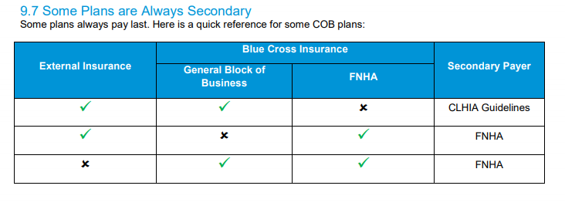

**DND response:** Members are not covered under any existing provincial health/insurance plans. Inquiries directed to DND are reviewed and approved on a case-by-case basis.

**RCMP Response**:

-RM, S/Cst. are entitled to supplemental health care which is reimbursed by the RCMP.

-RM, S/Cst. and CM who are injured in the performance of their duties are entitled to occupational health care which is reimbursed by the RCMP.

-Respective provincial/territorial governments are the payer for BHC entitlements

**NIHB**

1. I have a question regarding NIHB billings.  NIHB is a ‘biller of last resort’ – in that when an individual has extended benefits – they must use their extended benefits first and then go to NIHB to apply for the remainder of the funds.  This process is unclear to us as well as within PBC (who is now managing NIHB billings).  We had a client who had this particular issue and they (PBC) required us to apply and be denied and then go to the extended benefits.   In the end it worked out but it delayed services by several months due to the confusion on the procedure at Blue Cross.  This can’t possibly be the first instance that an individual has both types of coverage.  There needs to be clear steps in how this scenario is dealt with so that individuals can receive care in a timely manner.  Having to apply only to be denied delays care and frankly appears to be a case of systemic racism in my opinion.  It delays care and creates unnecessary hoops to jump through.   It also needs to be clear on how the aids are ordered – if the first payee is going to be extended benefits – we can’t go to the manufacturer and ask for NIHB pricing as this is not really true.   Hope this makes sense.  Happy to discuss further if clarification is required. (BC)

**NIHB response**: This question should be referred to the FNHA in BC as they administer benefits for First Nations clients in BC.

*Note: This question was subsequently moved to the FNHA section.*

1. Can you charge NIHB increased fees, or fees at all, that you do not charge private pay clients? E.g., can you charge a fitting fee to NIHB when you are not charging private pay clients for this? (NU)
   1. Additional information received for this question:
      1. Increased fees doesn’t mean charging a fee higher than NIHB maximum price. What I meant is charging NIHB a higher fee than would be charged to other payers for the same item.
      2. What I was told here by higher ups is that we are not going to charge private pay clients fitting fees because they are poor and the territory will therefore cover service fees, though the client still has to pay for the hearing aids themselves. We don’t actually bill the territorial government for the fitting fees because we are the territorial government. However, we are charging NIHB for the fitting fees, under the rationale that the territory does not cover stuff NIHB covers. It still sounds like contract violation to me though, because that’s contrary to what I read in NIHB policy. In addition, we have a territorial program for non-indigenous clients that covers hearing aids, and we do bill that program, but we don’t bill them fitting fees. I can see how these practices come from an altruistic place, but if they violate contracts with NIHB, we’re not being very accountable with federal money and this could have negative consequences later.
      3. As another request, it would be really nice to restrict the prior approval application to one page again with more lines for different items, and actually title it as prior approval APPLICATION. It’s confusing for new admin the way it is now and we don’t have the luxury of consistent admin or audiologists.

**NIHB response**: i. Providers may bill the NIHB program for eligible benefits and services according to the fees outlined in the price files located on the [Express Scripts Canada website](mailto:https://nihb.express-scripts.ca/NIHBProvider/benefits/msne?page=msnepricefiles-grid&benefit=msne) (ESC). ii. The Program cannot comment on billing practices outside of NIHB processes. iii. NIHB reviews its forms regularly and your suggestion will be considered in the next iteration.

1. If a client has First Nations or Inuit status but is not yet eligible for replacement for new hearing aids covered by NIHB, should you tell the manufacturer to charge the NIHB price to the client when they pay privately, or should they be charged the same price as non-status private pay clients? (NU)

**NIHB response**: If an NIHB client requires early replacement hearing aids (e.g. less than 5 years), the provider should complete a Prior Approval form and provide a justification as to why replacement hearing aids are needed. Exceptions can be reviewed on a case-by-case basis. If the NIHB client chooses to pay privately, they would be subject to the same prices as other private pay clients.

1. A client with First Nations or Inuit status is not eligible for NIHB replacement and chooses to pay for a replacement hearing aid privately. The province or territory covers fitting fees for clients without First Nations or Inuit status. Should the client be charged a fitting fee or can the fitting fee be charged to the province/territory? (NU)

**NIHB response**: If an NIHB client requires early replacement hearing aids (e.g. less than 5 years), the provider should complete a Prior Approval form and add a justification as to why replacement hearing aids are needed. This should be the first step before a client considers to pay privately. The NIHB Program will only pay fitting fees when the items (hearing aids) are eligible for coverage. The Program cannot comment on billing practices outside of NIHB processes.

1. I am looking into funding for Nunavut adult residents to receive BAHD/CI surgery down South. We are currently being told that the billing process changed 3 years ago and it is no longer possible as there isn’t a way to bill for the surgery/implant. There is confusion of if this applies to adults only, includes pediatric, and if it applies across all three regions of Nunavut or just with Baffin patients trying to be seen in Ontario. We are being told by Ottawa Civic Hospital that the surgery/implant now needs to be billed to NIHB when previously they were writing a letter to the minister of health in Nunavut and receiving funding via territorial money. We believe this is incorrect; to our knowledge, NIHB only covers the cost of the processor, not the surgery or implant. Hopefully this can be addressed and resolved quickly as there have been patients that need these surgeries for 3+ years now that have not received them. (NU)

**NIHB response**: Approximately 3 years ago, NIHB added cochlear implant (CI) and BAHS replacement processors as benefits of the Program for children and adults. This was announced in the [MS&E Newsletter](mailto:blob:https://nihb.express-scripts.ca/325008f7-c7a1-4d81-b433-28eee6ba7079)  available on the ESC website. It appears this may be have misinterpreted by some to mean that NIHB covers CI and BAHS in their entirety, which is incorrect. Surgical implants remain an exclusion of the NIHB program.

NIHB was recently made aware of this situation and received confirmation from a representative of the Government of Nunavut that they are aware of what is covered under NIHB vs their own insured services which include the surgery and the implant.

1. *Re: Express Scripts Canada (ESI).* Why is there only 30 days to submit from date of Prior Approval? It needs to be extended for at least 3 months. (SK)

**NIHB response**: In order to address this question, please ask the member to clarify what submission they are referring to, within 30 days. For manual claims, providers have 1 year to submit for payment. *After clarification:* This issue was discussed internally and unfortunately extending the length of time for online submissions is not a viable option at this time due to system limitations.

1. *Re: Prior Approvals Department.* Is a letter required ahead of time for evals that are needed that are out of frequency and then faxed to Prior Approvals? Out of Frequency Re-Evaluations that are for medical reasons, we can’t perform a hearing test and submit for Prior Approval as the clinic will be out of pocket for this if it is denied. Last time I requested this they asked for the evaluation. For example: We know one patient is unable to pay however the re-evaluation is needed due to medical reasons and refitting of hearing aid. (SK) *Additional clarification on the question:* For NIHB, we have had need for certain patients to come back for frequent hearing tests due to medical reasons.  Prior Approvals asks us to do the hearing test first and then send in the prior approval.  However, It’s almost impossible to get the patient to come back and pay for this service once they have left if the re-evaluation is denied.  I tried once to send in a prior approval request without doing the hearing test first and got a letter back saying the hearing test was missing.  Is there a better way to do this or is this something that will be the patient’s responsibility to pay for?

**NIHB response**: In addition to the Prior approval form, requests for benefit coverage outside of frequency requires supporting documentation for approval (e.g. client diagnosis, medical condition, justification as to why additional testing is required). The Program has consulted the NIHB SK region.  According to NIHB policy, a service should not be rendered  to a client without prior approval (unless it is an open benefit and within frequency). In the case where a hearing (re)assessment is needed out of frequency guidelines, a PA along with the medical justification should be submitted prior to doing the testing. The medical justification should include the reason the additional assessment is needed.

In the case where a client may require several (re) assessments out of frequency, the provider should indicate this in the justification along with the proposed frequency schedule. The PA and medical justification, if approved, will be filed at the SK NIHB region.

1. *Re: Battery***.** With newer technology, the battery life has been shorted significantly for hearing aids.  Batteries that used to last seven days are now lasting 2-3 days. Since NIHB patients can only get batteries every so often, this causes them to have to buy their batteries out of pocket or not wear their hearing aids every day.  I have been finding that NIHB patients do not pay for additional batteries and is instead going without (hearing aid data logging confirms this). I realize that you can apply for extra battery coverage, but that is a ton of extra work for our billing staff and often takes multiple submissions to get paid.  The battery issue has also caused patients to lie about getting batteries from the pharmacy so that when we go to submit, they are not eligible, or we end up losing money because we cannot bill for them. (SK)

**NIHB response:** Currently, the NIHB program covers batteries at a frequency of 24 every 144 days (for an average of one battery every 6 days). While this amount may be enough for some hearing aids using certain batteries sizes, NIHB will perform a review of the battery coverage to determine if the replacement guidelines require a revision.

1. *Re: Online billing.*We are still finding issues with the ESI website and even the SK NIHB people are telling us not to use the website because there are so many problems and still fax the invoices in.  Is this going to address soon so it is useful? (SK)

**NIHB response**: There have been some issues with the ESC Portal in the past but these have been resolved. If there continues to be problems, please identify the specific issues the provider is experiencing with the ESC website in order to facilitate our investigation.

1. *Re: Online ability to check status.* It would be great to have the ability to check to see if an NIHB patient is eligible for a complete hearing test or reassessment, batteries, or hearing aids without having to call. Often, we have 15 NIHB patients seen in one day, so we will call to check their eligibility. This can take a long time. If we could check online, it would save us from taking up valuable call time with NIHB representatives. (SK)

**NIHB response**: Currently this functionality does not exist however we have raised the question with NIHB’s Operational Services and Systems Department and they will investigate the feasibility.

1. *Re: Wait time on phone.* This is like what I just mentioned in my last point. We often must wait 30-45 minutes to talk to someone at NIHB to verify eligibility. *Additional clarification post-meeting:* The calls are being made to NIHB in Regina, not to ESC.   The times can vary, I would say most often around 10:30-11:30 am or 1:30 -3 pm but often we are calling when the patient has come into the clinic to pick up supplies so that would be anytime between 9 am-4:30 pm. (SK)

**NIHB response**: The SK NIHB region reports current phone wait times of approximately 5 minutes. If long wait times persist on a regular basis, we would ask that the provider note some specific days and times that this is occurring and NIHB can look into it further.

1. *Re:**Reciprocity/Pre-Approval for Implant Surgery.*  Have there been any recent changes to the pre-approval process for cochlear implant candidates from Nunavut who receive surgery in adjacent provinces?  Typically, surgical centres (or provincial health systems) receive reimbursement from Nunavut after performing surgery on out-of-province patients.  However, centres have been recently told by the Nunavut Department of Health that NIHB pre-approval for the internal implant is required before proceeding.  Any additional information on this is appreciated. (NU/ON/MB)

**NIHB response**: The NIHB Program covers the cost of cochlear implant replacement processors and BAHS replacement processors. Surgical implants remain an exclusion of the Program.

1. I have a question regarding NIHB. When a patient’s hearing aid breaks out of warranty and the issue is the receiver (receiver in the ear style hearing aid), we can replace that in clinic, but NIHB does not have a code so we can bill for this service. VAC does. The only option is to send the whole hearing aid to the manufacturer and they can replace it and we can charge an out of office/out of warranty repair charge, but then the patient is without it for 7-10 days and it costs more so it is not ideal. Advice on this would be greatly appreciated because when we called NIHB they did not know what to tell us. (NS)

**NIHB response**: NIHB is currently developing codes for replacement receiver tubes (code to be used when out of warranty). Once these codes are implemented, they will be added to the price files found on the ESC website. This will also be communicated in an NIHB publication (newsletter or bulletin) and updated on the [NIHB Guide and Benefits List](mailto:https://www.sac-isc.gc.ca/eng/1585321635593/1585321656771%23s2-4) on the Government of Canada website. **Update:** NIHB now has codes for replacement of receiver tubes (for hearing aids out of warranty). The codes are:

99401326            RECEIVER TUBE REPLACEMENT-LEFT

99401327            RECEIVER TUBE REPLACEMENT-RIGHT

**VAC**

1. DVA; code 320420 for amplified telephones needs to have the pricing reviewed as most of the third party vendors that we purchase these from have increased their price.  Including the markup for this code the max is $250. (ON)

**VAC Response**: From an initial review, indications are that VAC’s rate is reasonable. We are wondering if you can provide additional information e.g. examples of products being cutback? This benefit item should be the Manufacturer cost plus a 40% markup to a maximum of $250.

*Clarification from member:* I have recently found a company that honours the DVA pricing, which we will use going forward.  Thus we won't need to pursue this any further.

1. The other code to be reviewed is 320440 (shipping other) the max for it is $10 and the shipping for the assistive devices has increased and is often $12-15. (ON)

**VAC Response**: From an initial review, indications are that VAC’s rate is reasonable for the majority of situations. We understand that there may be exceptional circumstances and in those cases, a Provider can submit a request for authorization of shipping over the limit to the Medical Authorization Centre at Medavie Blue Cross with supporting documentation from the shipping company.

1. It would be nice on the portal when submitting claims that we have access to those claims within the same business day to make adjustments to the claim for corrections. (ON)

**Medavie Blue Cross Response:** Thank you for the feedback / suggestion. Enhancements are being looked at for the provider portal. At this point, it has not been determined what those changes / enhancements will be. Most of 2021 will focus on a portal refresh, once that is complete more details will be available.

**FNHA**

1. The fillable PBC FNHA Claim/Pre-determination form there are glitches in the **DIN/PIN/ITEM CODE** column.  PBC is requesting the service code but the fields will only accept a date. See below:

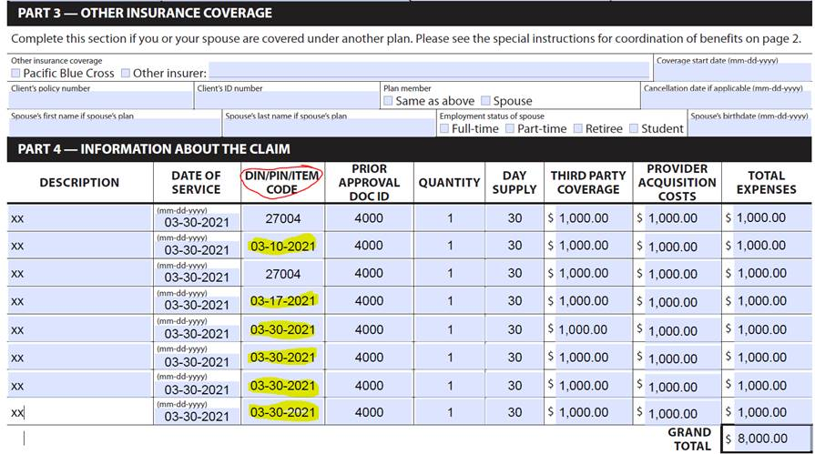

All other fields on the form are accessible.  (BC)

**FNHA Response:** This will be flagged with our provider for review and investigation. Once resolved, we can advise the group. **Update:** After a review, PBC was unable to duplicate the issue. If the provider is still experiencing issues, please advise them to Help Desk team at 604-419-2000 or 1-877-722-2583.

1. Clarify the age of a pediatric client and subsequent adult client?  Is it 18 years? Phonak bills a peds fee and adult different fee. (BC)

**FNHA Response:** Yes, we would consider individuals under the age of 18 as Pediatric for billing purposes, over 18 can be billed as an adult. Current fee schedule is not entirely clear, so a review will be conducted.  But for now, the distinction for adult cases is > 18 years of age.

1. The dollar max/frequency for ear molds is $45.00 and limited to 1 every 5 years per left and right ear and *must be for a new hearing aid*.  Our **average** price from Oto for an ear mold is **approximately $55.00 each**, can be more depending. (BC)

**FNHA Response:** An exception can be requested by contacting provider support. Documentation may be required to support the higher acquisition cost.

1. Eligibility for new hearing aids is limited to 1 every 5 years per left and right ear. (BC)

FNHA Response: A clarification of the policy has been included. Fee schedule for replacement hearing aid(s) will not be changed in the near-term, but early replacement can be submitted for prior approval with medical justification and will be reviewed on a case-by-case basis. If there are further questions, please advise.

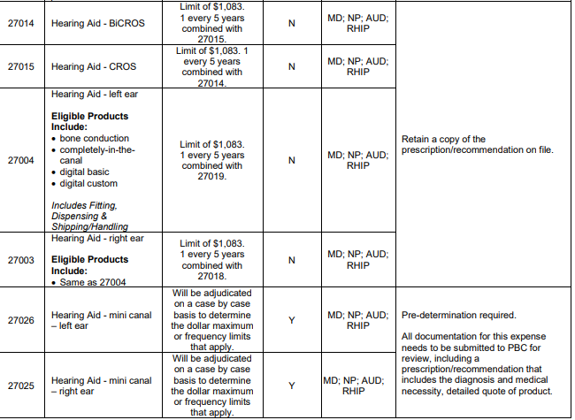

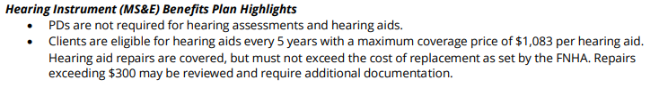

1. When a call is placed to PBC FNHA they are very helpful and take the time to be sure you get the information you were looking for.  The same can be said for assistance from the First Nations Health Benefits contact number, I have left messages and they have all been returned.  Excellent service. (BC)

**FNHA Response:** The response has been noted and appreciated.

1. *(Note: this questions was moved from the NIHB section.)* I have a question regarding NIHB billings.  NIHB is a ‘biller of last resort’ – in that when an individual has extended benefits – they must use their extended benefits first and then go to NIHB to apply for the remainder of the funds.  This process is unclear to us as well as within PBC (who is now managing NIHB billings).  We had a client who had this particular issue and they (PBC) required us to apply and be denied and then go to the extended benefits.   In the end it worked out but it delayed services by several months due to the confusion on the procedure at Blue Cross.  This can’t possibly be the first instance that an individual has both types of coverage.  There needs to be clear steps in how this scenario is dealt with so that individuals can receive care in a timely manner.  Having to apply only to be denied delays care and frankly appears to be a case of systemic racism in my opinion.  It delays care and creates unnecessary hoops to jump through.   It also needs to be clear on how the aids are ordered – if the first payee is going to be extended benefits – we can’t go to the manufacturer and ask for NIHB pricing as this is not really true.   Hope this makes sense.  Happy to discuss further if clarification is required. (BC)

**FNHA Response:** FNHA is also designated as the payor of last resort. This means that an individual needs to exhaust any other available coverage first before the FNHA plan would step in. In cases where an individual has group insurance through an employer, it is standard practice to apply to other insurers first. Confirmation of coverage (or noncoverage) from the other plan is provided as a “Statement of Benefits” to PBC before they will initiate and pay the claim. This process is not unique to FNHA and is standard practice for members of the Canadian Life and Health Insurance Association (CLHIA).

If incomplete or incorrect information was given on how to navigate that process, we apologize. If there are specifics that can be shared separately (ensuring confidentiality), we can ensure that feedback is provided to the appropriate parties and that training is provided.

**RCMP** (no questions)

**DND/CAF** (no questions)

**Additional Questions from the Meeting:**

1. Are DND/VAC planning on changing policy to cover CIC hearing aids?

**DND response:** No plans to change current policy on CIC coverage.  Reason: military members are often away from primary residence for long periods of time and repairs take an inordinate amount of time to be processed.  The cost of repair is not the primary concern, it is potential for repair frequency.

**VAC response:** VAC’s policy is that CIC style hearing aids may be provided for eligible Veterans. CIC aids require pre-authorization from VAC. Part of the pre-authorization requirements is that there is a demonstrated health need for the style of hearing aid.