Instrument of Proxy
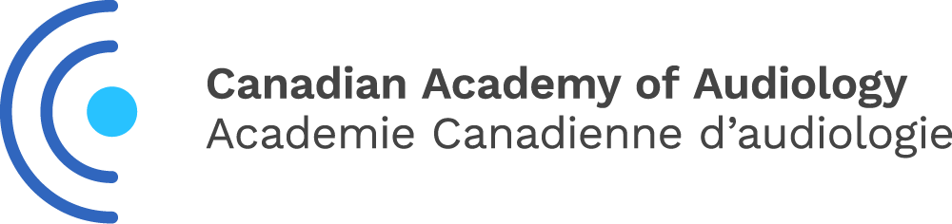

I, ___________________________________________, a member of the Canadian Academy of
Audiology (CAA) hereby appoint ___________________________OR____ Chris Allan, President of CAA, as my proxy to attend, act and vote for me on my behalf at the Annual General Meeting of CAA, to be held the 22nd day of September 2022 and at any adjournment thereof, unless and until I am present in person and I hereby revoke any former instrument appointing a proxy for me at the said meeting or any adjournment thereof.

Dated this ________________ day of ___________________ 2022

Member Signature _____________________________________

Please forward to the CAA National Office by email,
to Dorcas Awoniyi dorcas@canadianaudiology.ca by September 15th, 2022.

Only full members, or early career members in good standing may vote.

