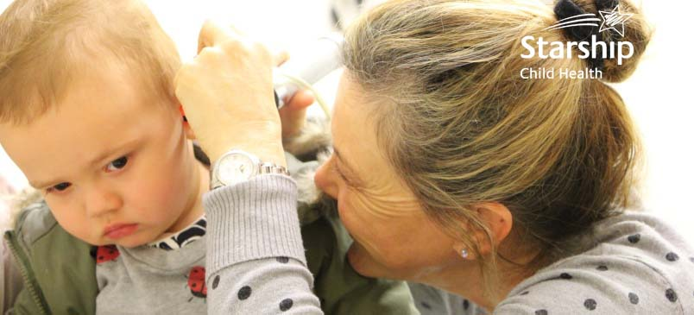
Audiologist, Starship Community
Here is a great opportunity to make a difference to our tamariki and their whānau!
- Permanent Paediatric Audiologist
- The Hearing & Ear Health department at Starship
- New Zealand's largest Audiology Service in the public sector.

Ko wai mātou | Our Organisation
We are Te Whatu Ora Te Toka Tumai Auckland. We provide health and disability services to more than half a million people living in central Auckland, regional services for Northland and greater Auckland, and specialist national services for the whole of New Zealand. Our main sites are Auckland City Hospital, Greenlane Clinical Centre and Starship Children’s Hospital, located in central Auckland
At Te Toka Tumai Auckland we are committed to upholding Te Tiriti o Waitangi and providing culturally safe care. We value role modelling manaakitanga as demonstrated by Ngāti Whātua in the gifting of their whenua on which our hospitals stand. We aspire to having a workforce reflective of the communities we serve and achieving equitable outcomes for all.
Starship Community provides multidisciplinary care and cultural support to children, young people and their whānau living within the Auckland DHB area. Our nursing, allied health and technical staff deliver health care services to children, young people, and their whānau in their home, school and community settings. A part of this service is the Hearing & Ear Health team consisting of our talented Audiologists; Newborn Hearing Screeners, Ear Nurses and Vision and Hearing Testers.

Te whiwhinga mahi | The Opportunity
As our service continues to grow, we are now looking for a qualified Audiologist to provide diagnostic and rehabilitative audiological services to a variety of patients with complex cases. We can offer a part-time position with 32 hours per week working across our audiology clinics in the Auckland community.

As an Audiologist you will undertake teaching and research tasks appropriate to the Audiology service; local community and hospital. You will work across all clinics/ sites to create and maintain working relationships with stakeholders within the service and wider ORL team.

As a service we offer:
- A comprehensive and well-structured orientation programme and a supportive and safe learning work environment.
- Considerable on-going opportunities to extend your current skills in a wide range of specialities including diagnostics, hearing aids and electrophysiological testing.
- Being the largest public sector Audiology service in the country, the exposure and direct experience we can provide is second to none.
- Opportunities to participate in clinical student teaching, in-service/ professional development and peer review.

For further information, please refer to the position description here.

Nga Pūkenga Motuhake | Important Skills
We welcome applications from those with:
- A professional qualification - Masters of Audiology.
- Prior experience and knowledge in audio logical techniques.
- Strong computer skills & an effective communication approach.
- A current, full & clean NZ driver’s license.

For more information about this role please contact Sarah Daye, Team Leader- Audiology & Newborn Hearing Screening via SDaye@adhb.govt.nz

He aha ngā painga o tēnei mahi mōu | Why you will enjoy working here
We recognise there is more to life than mahi | work, and we encourage and provide access to all our staff several services and benefits to support themselves whilst they are employed within Te Toka Tumai | Auckland DHB.

For more information on what we offer, please click here.

Me pēhea te tuku tono | How to apply
Please submit your application online, outlining your experience in your CV and motivation to apply to this role in your covering letter quoting the Job reference: ADHB16909

If you have any queries about accessibility, or technical issues with the online process, please contact Honey Pillai - Recruitment Consultant at HPillai@adhb.govt.nz

Advertising closes: 14 May 2023

For the biggest health sector job board in New Zealand visit www.kiwihealthjobs.com

