Instrument of Proxy
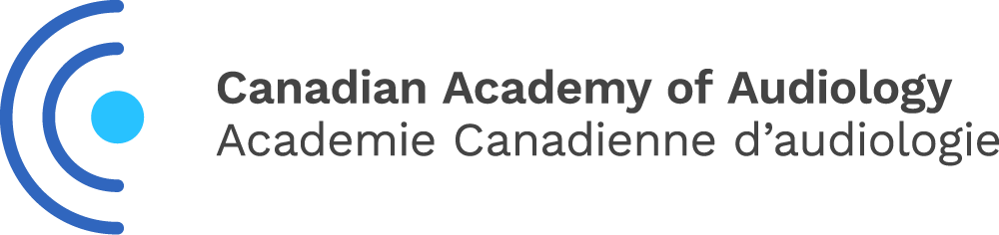

I, ___________________________________________, a member of the Canadian Academy of
Audiology (CAA) hereby appoint ___________________________OR____ Michael Vekasi, President of CAA, as my proxy to attend, act and vote for me on my behalf at the Annual General Meeting of CAA, to be held the 12th day of September 2024 and at any adjournment thereof, unless and until I am present in person and I hereby revoke any former instrument appointing a proxy for me at the said meeting or any adjournment thereof.

Dated this ________________ day of ___________________ 2024

Member Signature _____________________________________

Please forward to the CAA National Office by email,
to Dorcas Awoniyi dorcas@canadianaudiology.ca by September 5th, 2024.

Only full members, or early career members in good standing may vote.

